**YEAR 9 ECOLOGY REVISION**

1. Define the following, with examples:
   1. Population
   2. Community
   3. Dynamic equilibrium
   4. Food chain
   5. Food web
   6. Herbivore
   7. Carnivore
   8. Omnivore
   9. Decomposer
   10. Primary consumer
   11. Secondary consumer
2. Define the following relationships, with examples:
   1. Predator- prey
   2. Competition
   3. Mutualism
   4. Commensalism
   5. Parasitism
   6. Collaboration
   7. Competition
3. Draw an example of a food chain with four organisms. What direction do the arrows need to point and why?
4. On the food chain you drew for Question 3, identify the following:
   1. Producer
   2. Primary Consumer
   3. Secondary Consumer
   4. Tertiary Consumer (Apex Predator)
   5. Trophic Levels

5. Redraw your food chain as an ecological pyramid and indicate the trophic levels.

6. If 60 kJ of energy is available at the fourth trophic level indicate on your pyramid the energy available at all the other trophic levels

7. Where does the energy in your food chain originally come from?

8. For the following terms identify which are most likely to be herbivores, carnivores and omnivores.

1. primary consumer
2. secondary consumer
3. tertiary consumer

9. Name the two types of ecological pyramids.

10. Which trophic level is found on the bottom of an ecological pyramid?

11. What type of organism at the base of an ecological pyramid?

12. How is a pyramid of energy similar to a pyramid of numbers and how is it different?

13. How is an upright pyramid of numbers similar to an inverted pyramid of numbers and how is it different?

14. How much energy is passed on from one trophic level to another?

15. List two natural events that can affect an ecosystem. Explain the positive and negative impacts these events have on an ecosystem.

16. Describe two human activities that can upset the balance of an ecosystem?

17. Name two processes which cause populations to increase?

18. Name two processes which cause populations to decrease?

19. i) Describe the shape of the population graph given below

ii) Make an inference

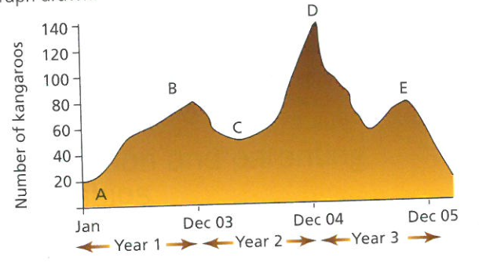

20. For the food-web over the page, answer the following:

a. Where does the energy enter this system (which organism)?

b. What is the source of this energy?

c. If a disease were to wipe out the clown-fish, what would happen to the populations of:

* + 1. Algae
    2. Blue Regal Fish
    3. Great White Shark

d. What would happen if the algae were to disappear?

e. What would happen if the Great Whites were to disappear?

f. Draw two separate food chains from this food web one with three organisms and one with four organisms.

